Lab Exercise 9- Create Service in Kubernetes

Objective:

- Understand the syntax and structure of a Kubernetes Service definition file (YAML).

Prerequisites

- Kubernetes Cluster: Have a running Kubernetes cluster (locally using Minikube or kind, or a cloud-based service).
- kubectl: Install and configure kubectl to interact with your Kubernetes cluster.
- Basic Knowledge of YAML: Familiarity with YAML format will be helpful for understanding Kubernetes resource definitions.

Step-by-Step Guide

NodePort Service

To expose the Service on a port on each Node in the cluster, modify the Service type to NodePort.

Create a YAML file named service.yaml with the following content:
service.yaml
apiVersion: v1
kind: Service
metadata:
name: nodeport-service
spec:
selector:
app: web
ports:
- protocol: TCP
port: 80
targetPort: 80
nodePort: 30007 # A specific port in the range 30000-32767
type: NodePort
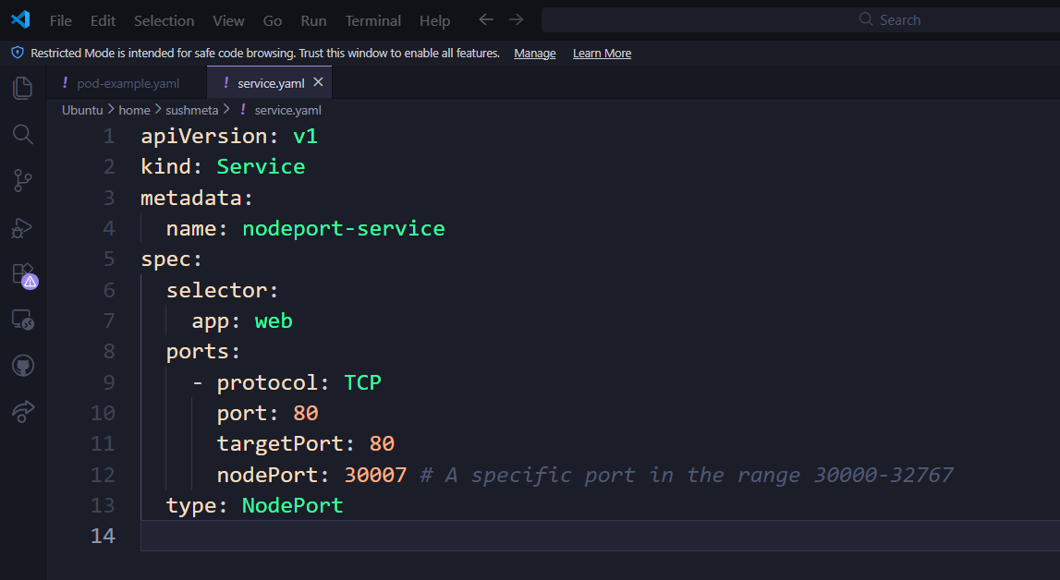

Explanation:

- The primary difference from the ClusterIP Service is the addition of nodePort, which specifies the static port on each Node.
- type: Set to NodePort, exposing the Service on a specific port across all Nodes.

Apply this YAML to create the NodePort Service:

kubectl apply -f nodeport-service.yaml

Verify the Service:

kubectl get services
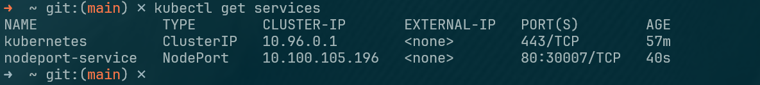

You should see the nodeport-service listed with a NodePort and details about the port exposed.

